RUBBER CHICKEN RACING GARAGE www.RubberChickenRacingGarage.com

QuikJump Kit Installation Instructions

Kit fits all BMW Oilhead models from 1993 to 2004 EXCEPT RT models.
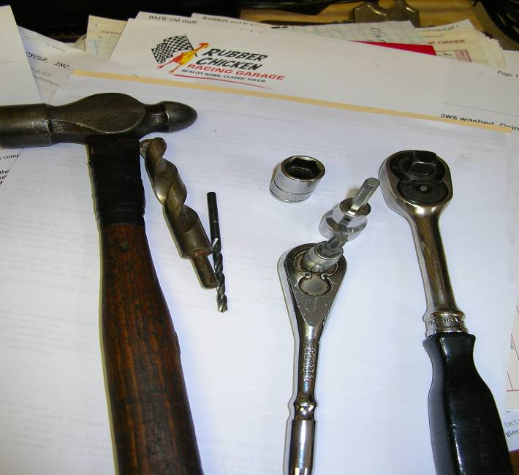
Tools needed:

5 mm Allen wrench or socket

Ratchet

T30 Torx driver or socket

13 mm socket or box-end wrench

light (6-8 oz.) ball-pein hammer

Drill motor- handheld or drill press

1/8” drill bit

½” drill bit

1) Disconnect ALL cables from Battery Negative (-) terminal. Cover terminal to prevent accidental contact while working.

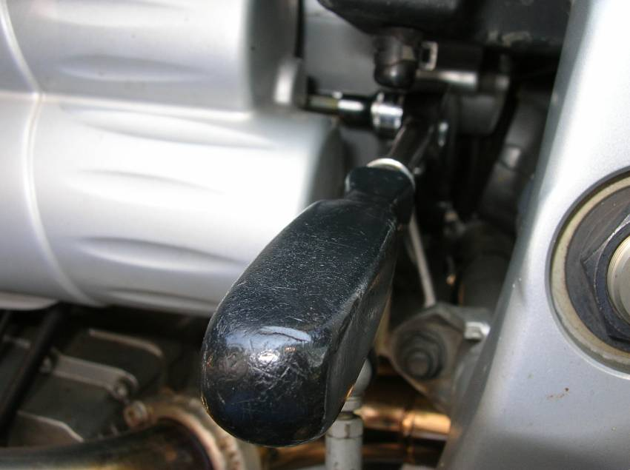
2) Remove Starter Cover retaining bolt.

3) Pull starter cover back ¾”, then tip cover out and off.

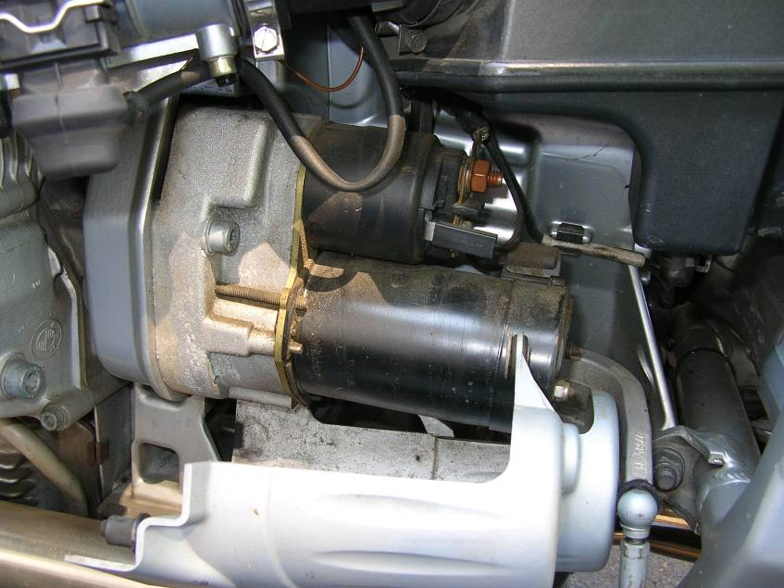

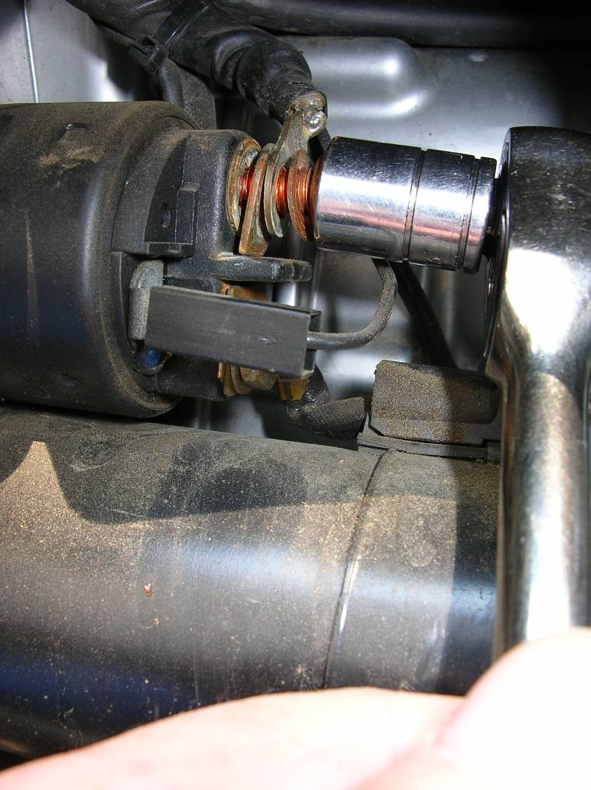

4) Disconnect battery cable from starter solenoid.

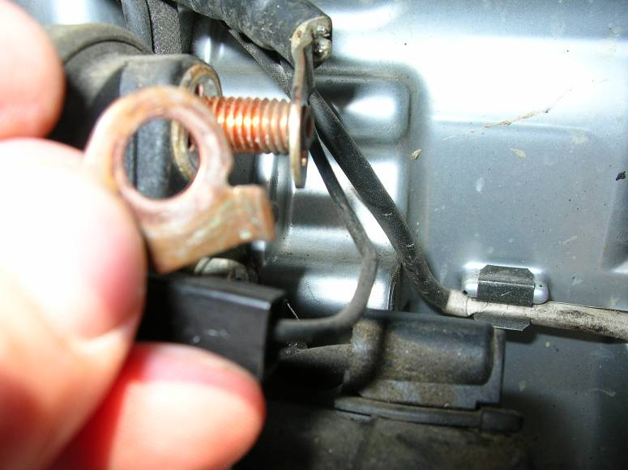
5) Remove cable locating plate and set aside. This plate will NOT be reinstalled.

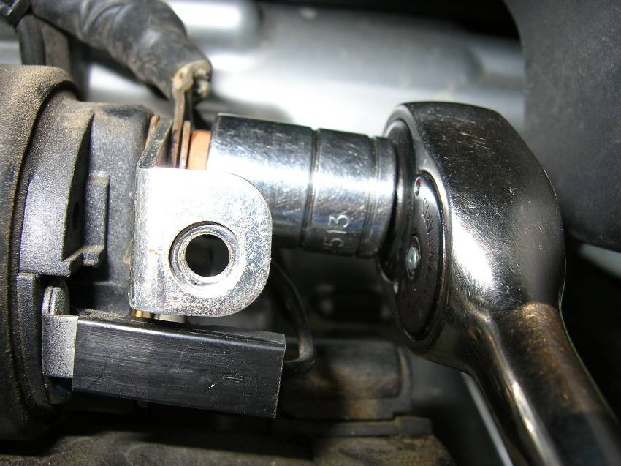
6) Install connector plate from kit. Note orientation of cable locating tab. Install washer and nut. Tighten nut gently. Do not over tighten, the solenoid is delicate.

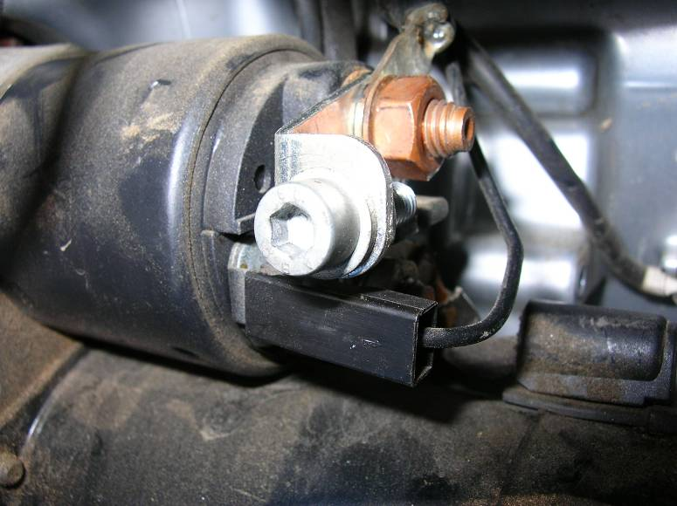
7) Temporarily install cover bolt into connector plate. Screw down finger tight only.

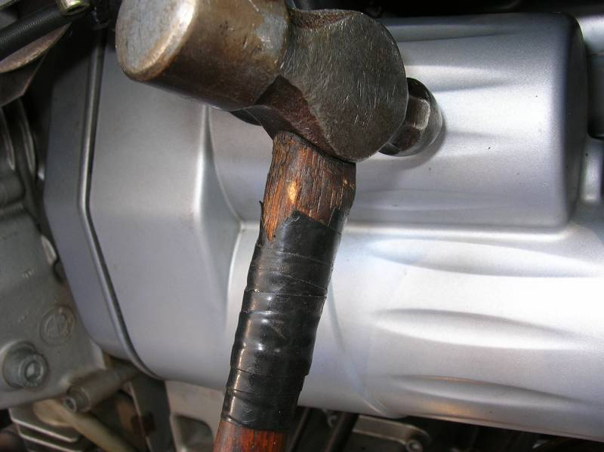
8) Temporarily reinstall starter cover into position. Do not install bolt. While holding cover in position, tap on the cover just where it touches the bolt installed in previous step.

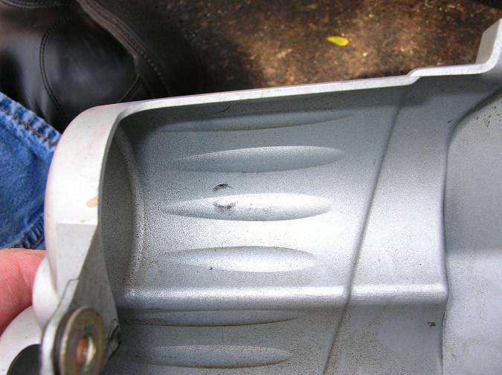
9) Remove cover and locate mark made in previous step. Remove cover bolt from connecting plate.

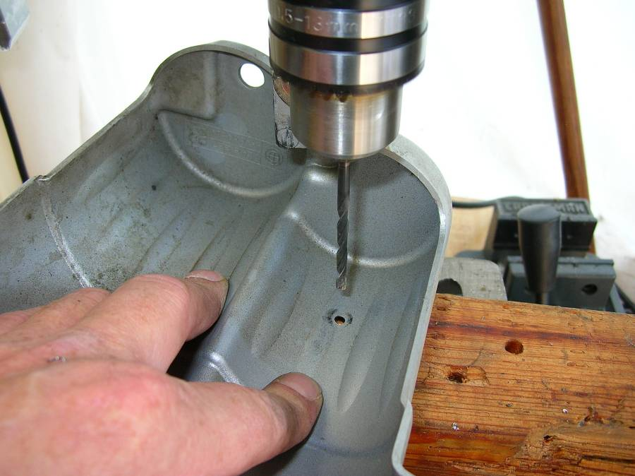

10) Drill center of mark with the 1/8” drill bit.

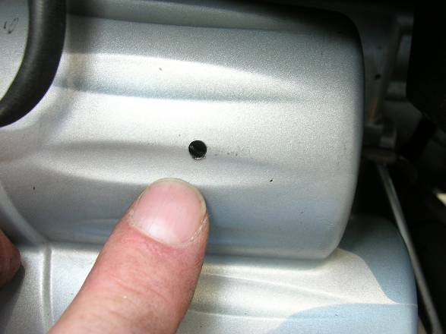
11) Reinstall starter cover, check alignment of pilot hole.

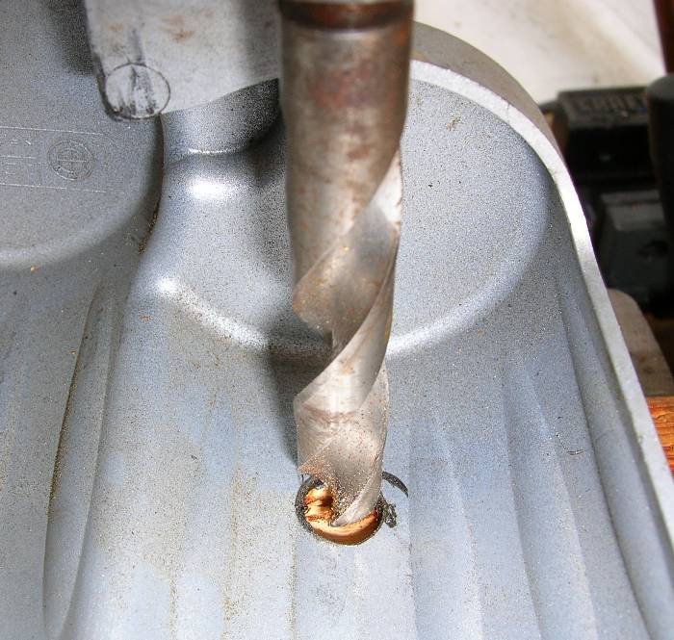

12) Adjusting hole position as needed, drill ½” hole through cover.

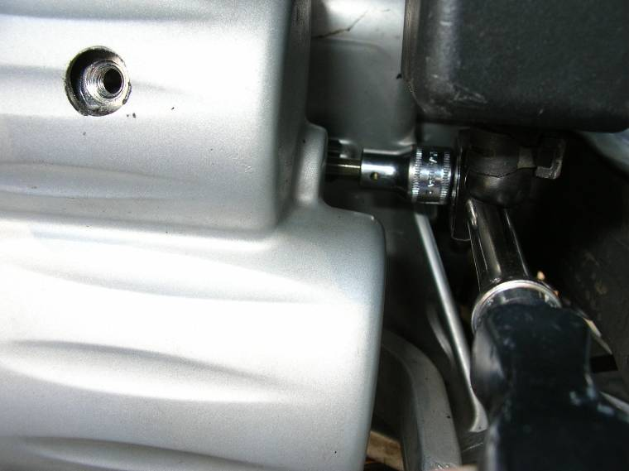

13) Reinstall Starter cover. Install and tighten cover retaining bolt.

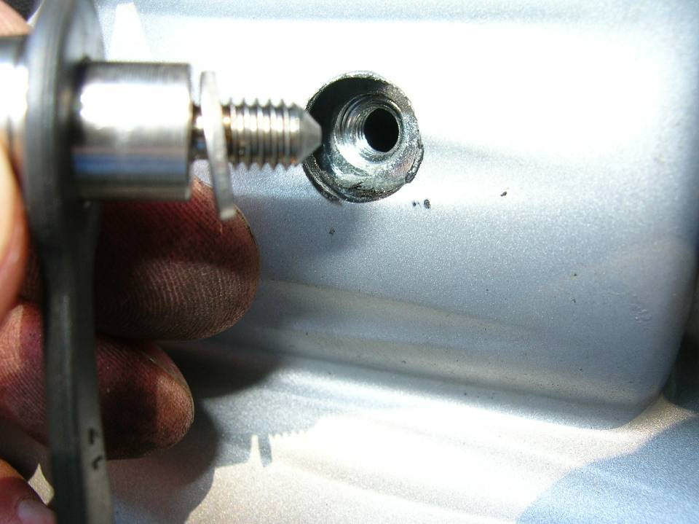
14) Install QuikJump Stud, washer and rubber cover.

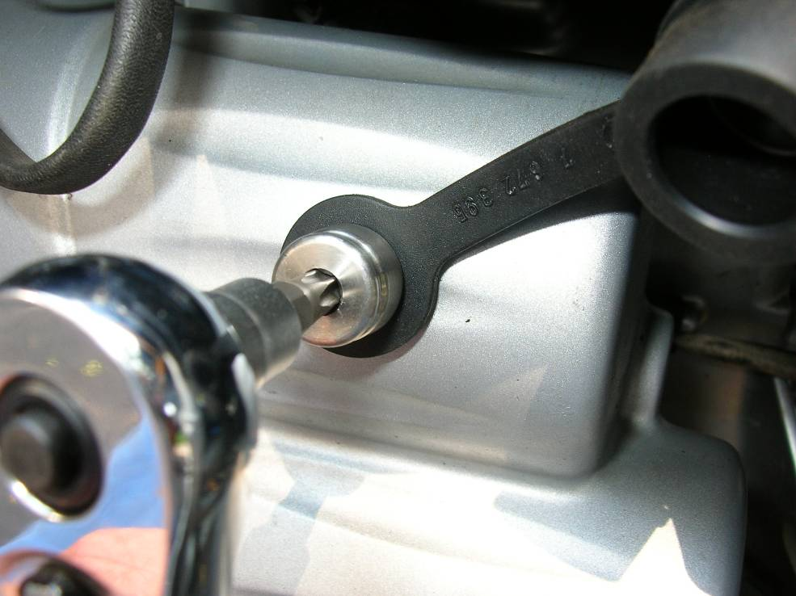
15) Tighten stud with Torx T30 socket.

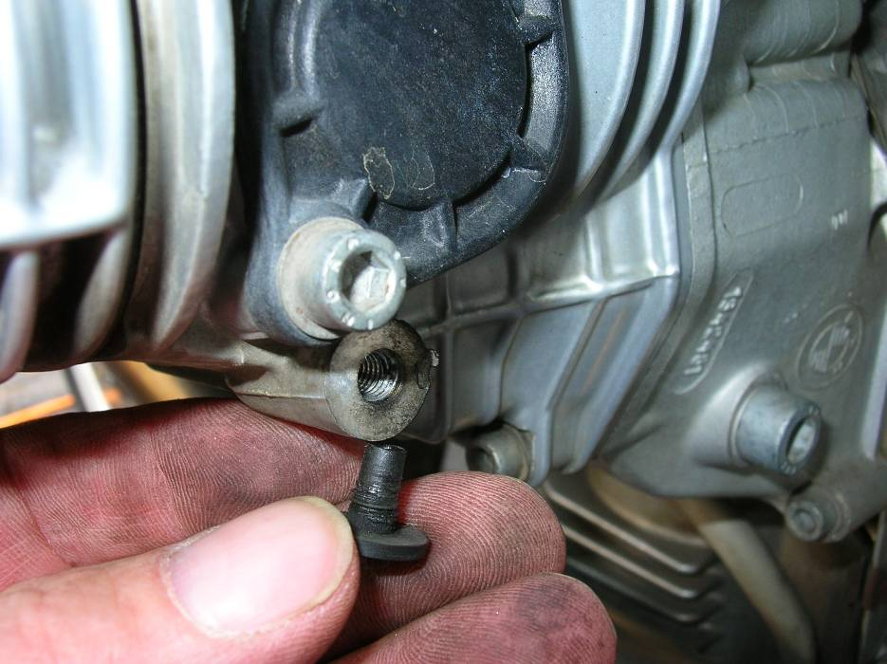
16) Locate and remove plastic plug on cylinder head.

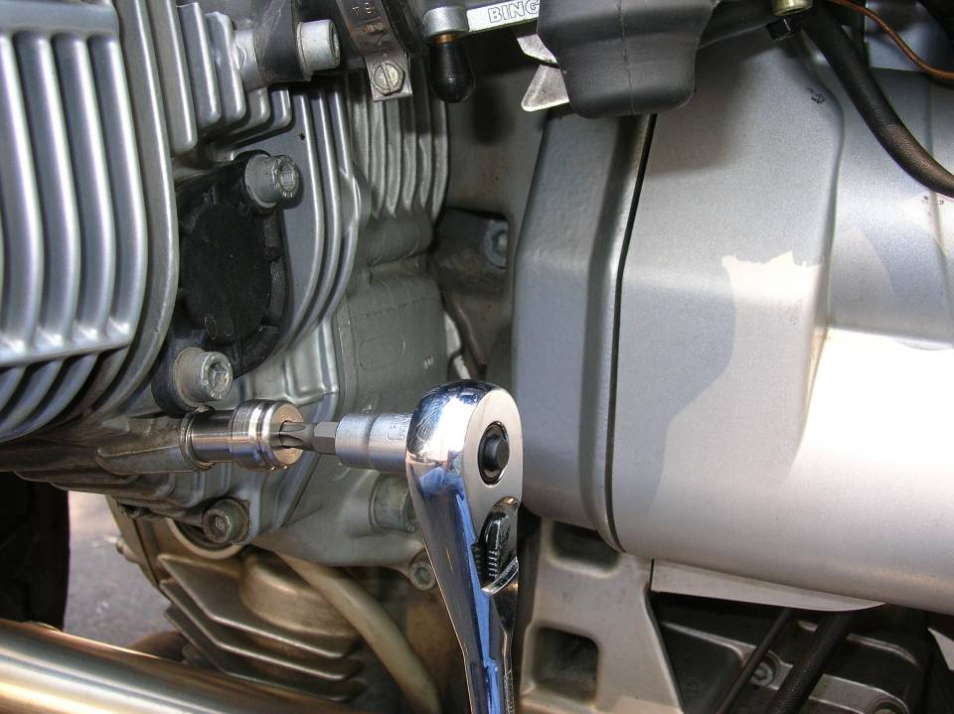

17) Install second QuikJump stud and washer into empty thread.

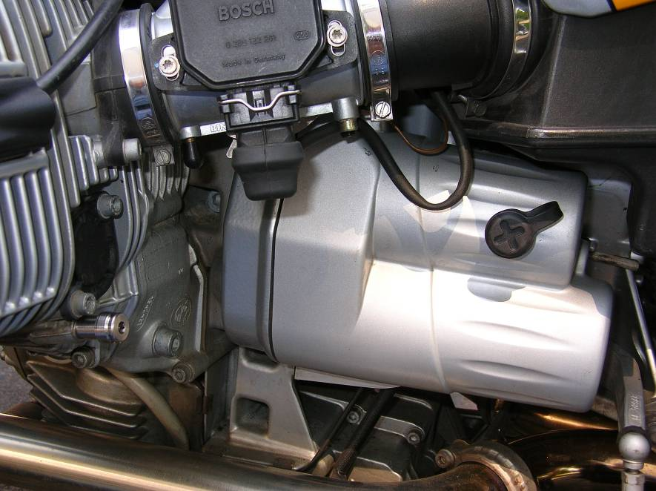
18) Finished installation showing rubber installed cover over positive (+) QuikJump terminal.

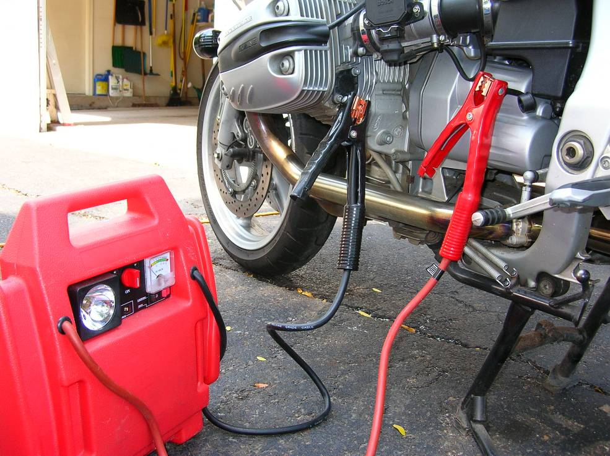
19) To use QuikJump Terminals, connect jumper cables as shown:

Copyright Rubber Chicken Racing Garage www.RubberChickenRacingGarage.com

